**EXPERIMENT NO. 9**

**NAME:** Arya Manoj Madhavi

**CLASS:** D15B

**ROLL NO.:** 31

**Aim:** To Understand Continuous monitoring and Installation and configuration of Nagios Core, Nagios Plugins and NRPE (Nagios Remote Plugin Executor) on Linux Machine.

**Installation of Nagios**

**Prerequisites:** AWS Free Tier

Steps:

1. Create an Amazon Linux EC2 Instance in AWS and name it - nagios-host

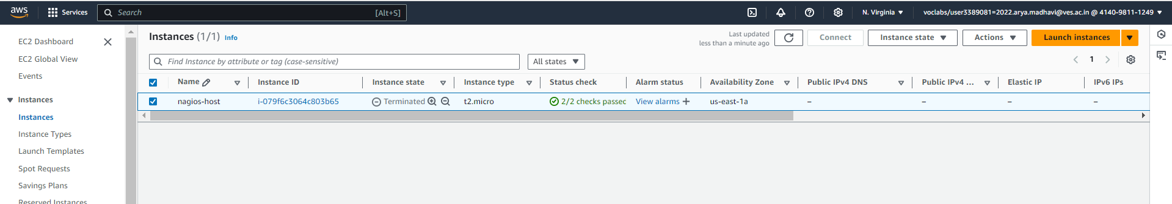

2. Under Security Group, make sure HTTP, HTTPS, SSH, ICMP are open from everywhere. You have to edit the inbound rules of the specified Security Group for this.

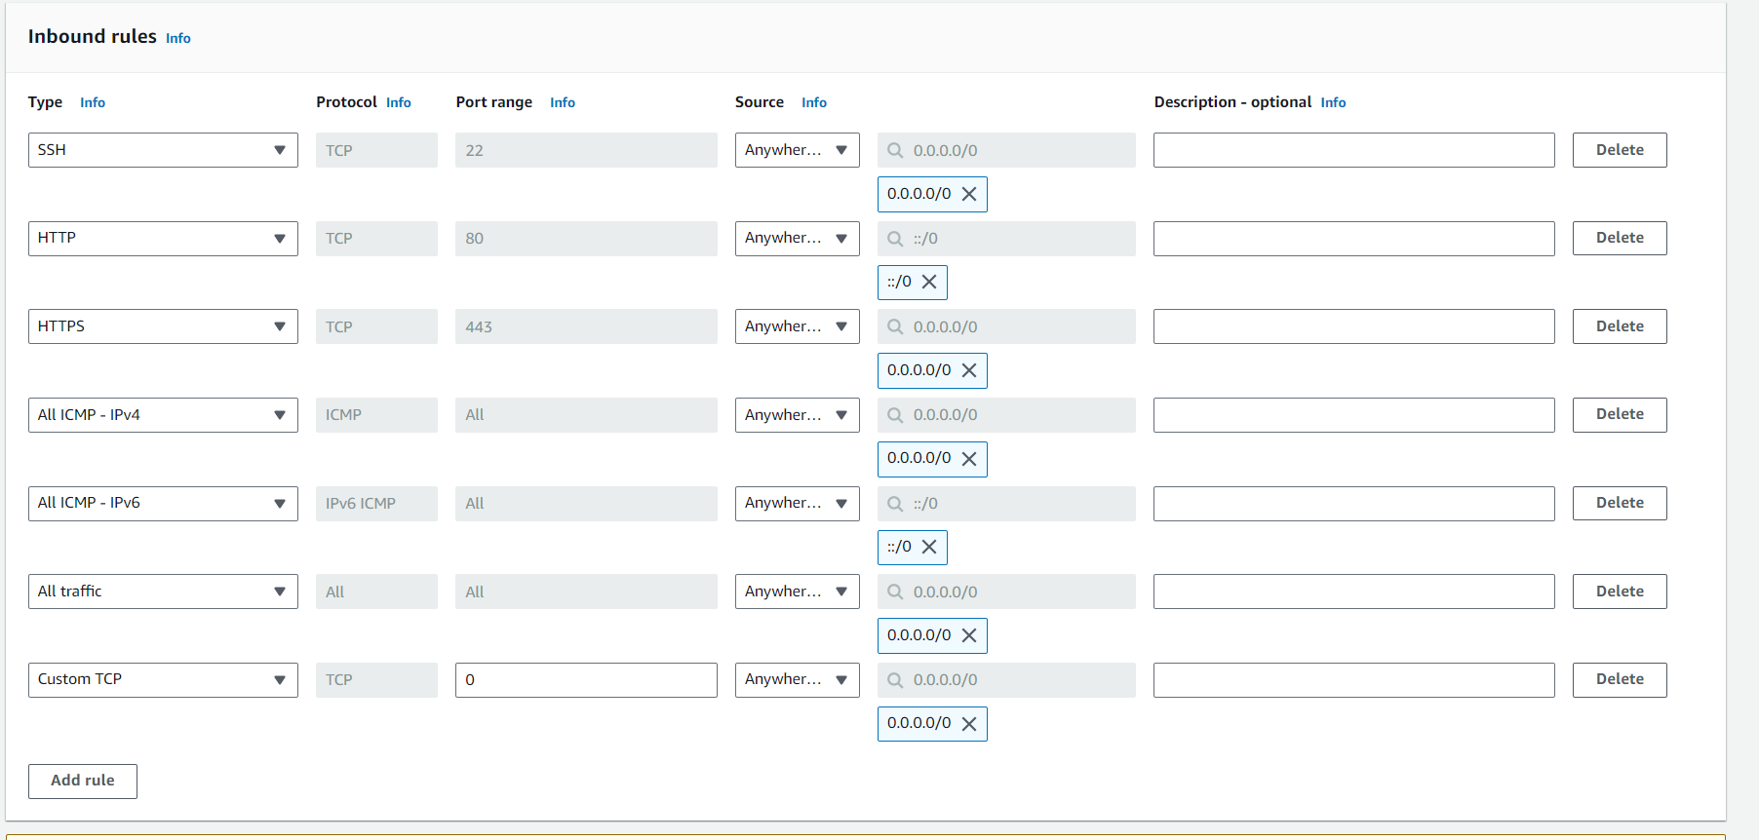

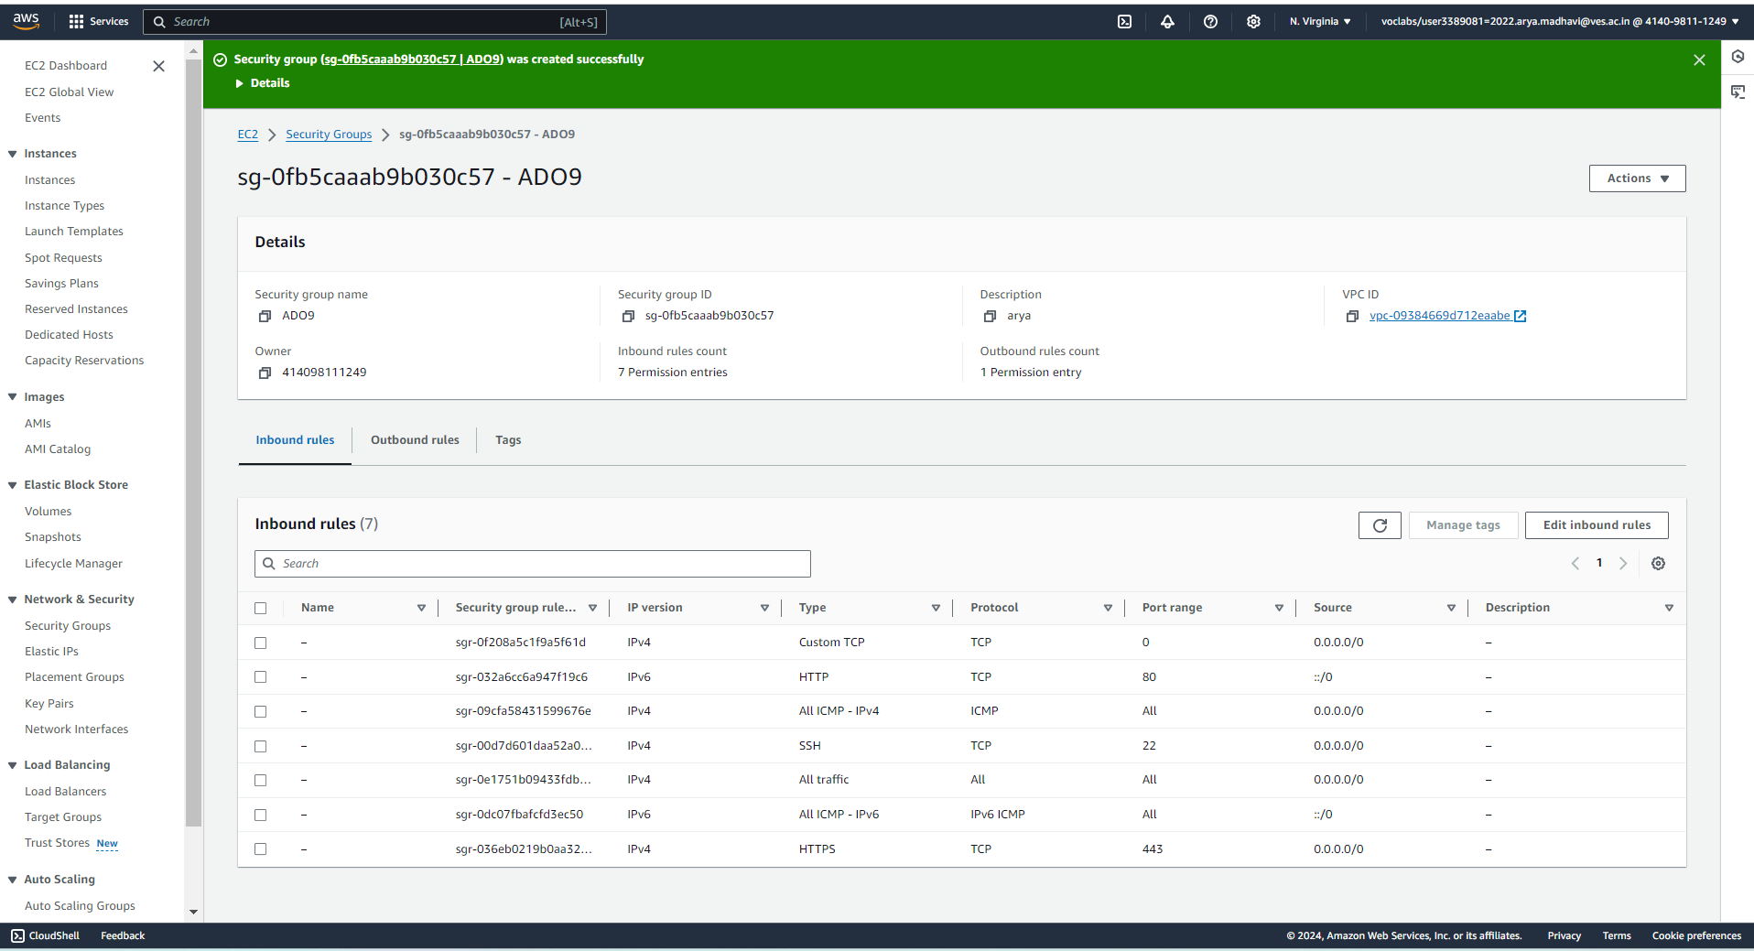

3. SSH into Your EC2 instance or simply use EC2 Instance Connect from the browser. 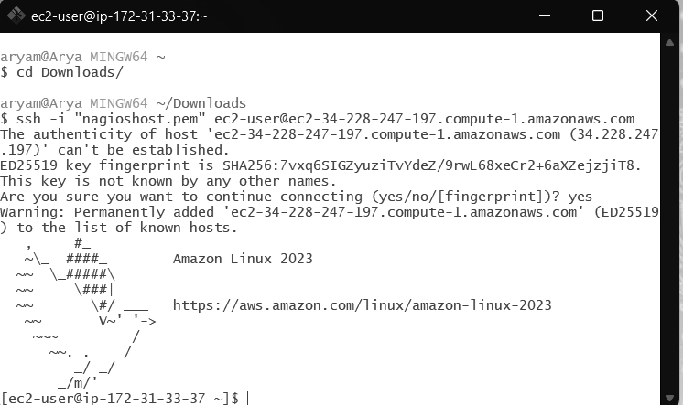

4. Update the package indices and install the following packages using yum

sudo yum update

sudo yum install httpd php

sudo yum install gcc glibc glibc-common

sudo yum install gd gd-devel

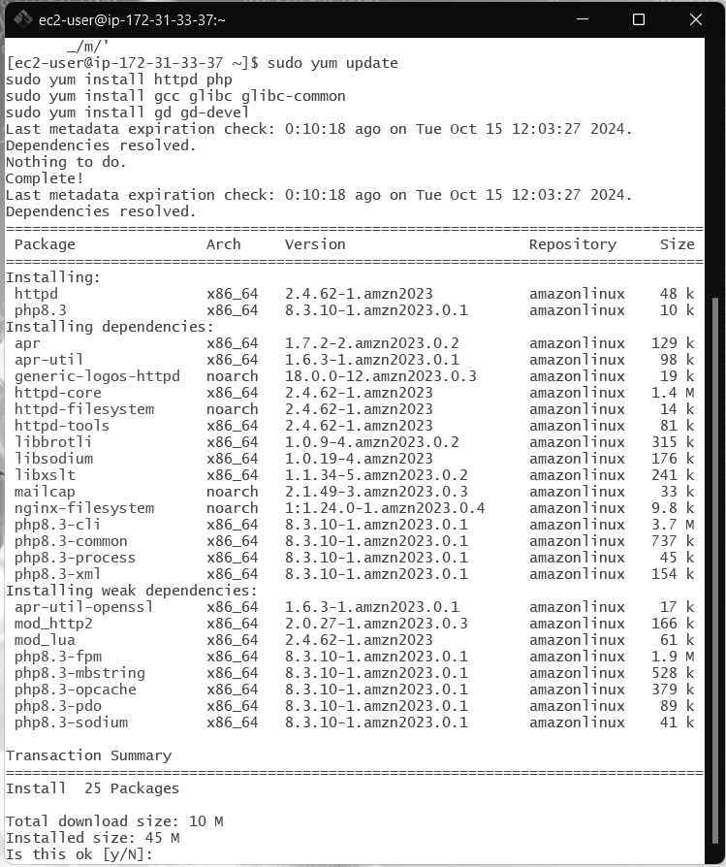

5. Create a new Nagios User with its password. You’ll have to enter the password twice for confirmation.

sudo adduser -m nagios

sudo passwd nagios

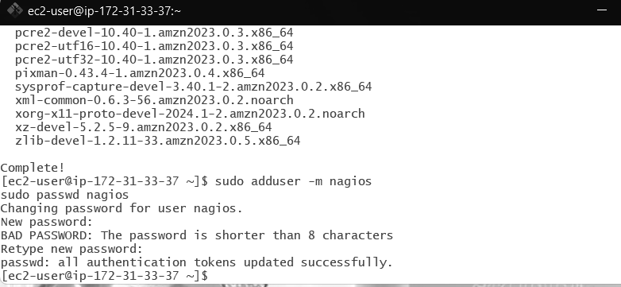

6. Create a new user group

sudo groupadd nagcmd

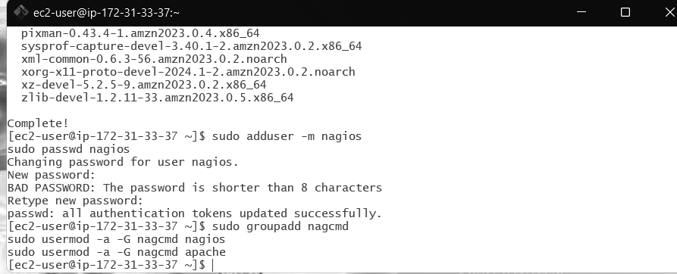

7. Use these commands so that you don’t have to use sudo for Apache and Nagios

sudo usermod -a -G nagcmd nagios

sudo usermod -a -G nagcmd apache



8. Create a new directory for Nagios downloads

mkdir ~/downloads

cd ~/downloads

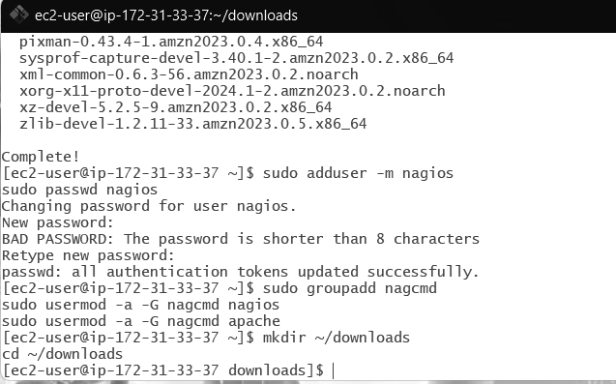

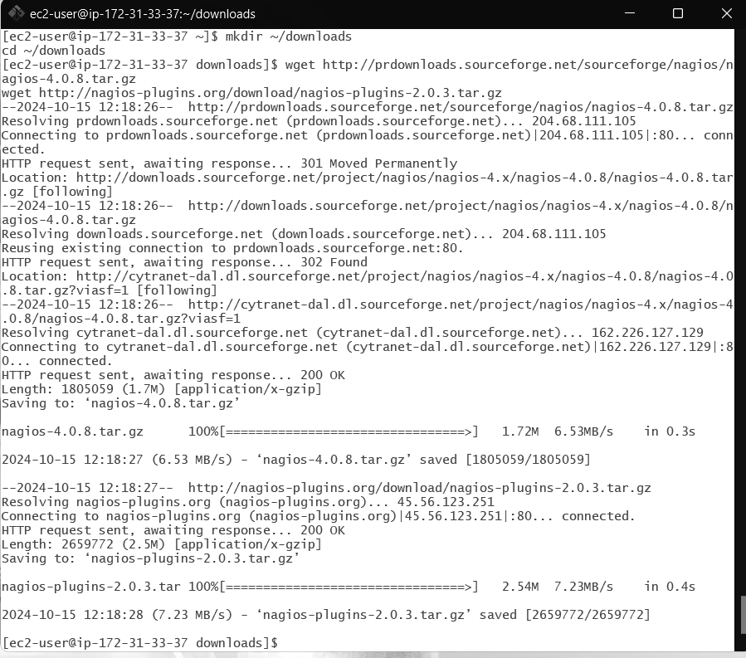

9. Use wget to download the source zip files.

wget

http://prdownloads.sourceforge.net/sourceforge/nagios/nagios-4.0.8.tar. gz

wget http://nagios-plugins.org/download/nagios-plugins-2.0.3.tar.gz

10. Use tar to unzip and change to that directory.

tar zxvf nagios-4.0.8.tar.gz

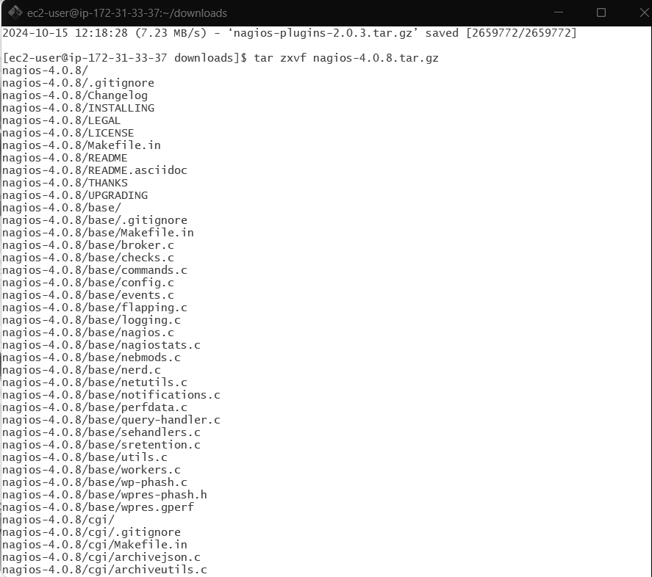

11. Run the configuration script with the same group name you previously created.

Cd nagios-4.0.8,

./configure --with-command-group=nagcmd

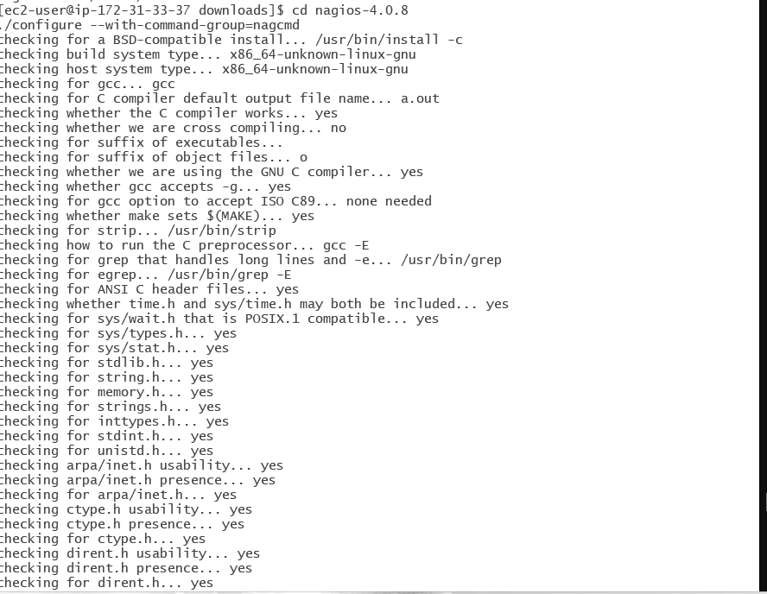

12. Compile the source code.

make all

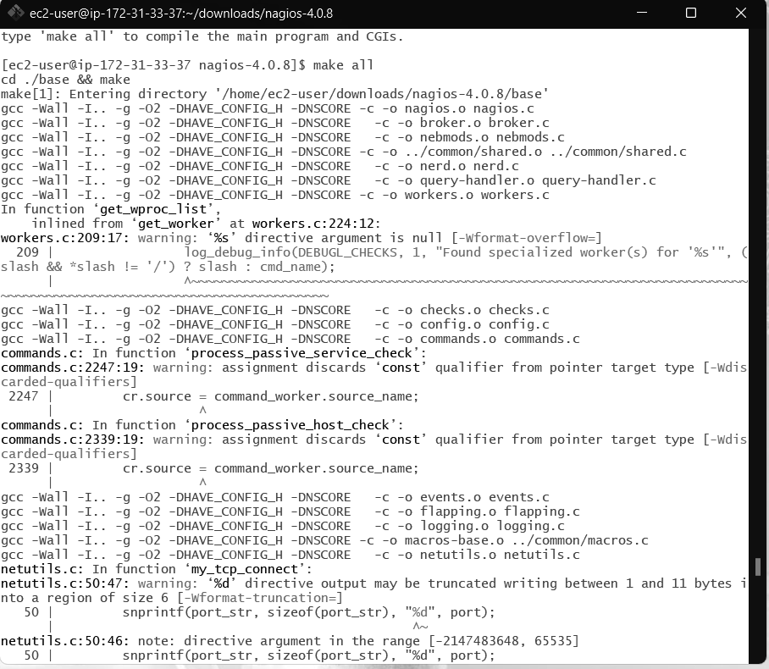

13. Install binaries, init script and sample config files. Lastly, set permissions on the external command directory.

sudo make install

sudo make install-init

sudo make install-config

sudo make install-commandmode

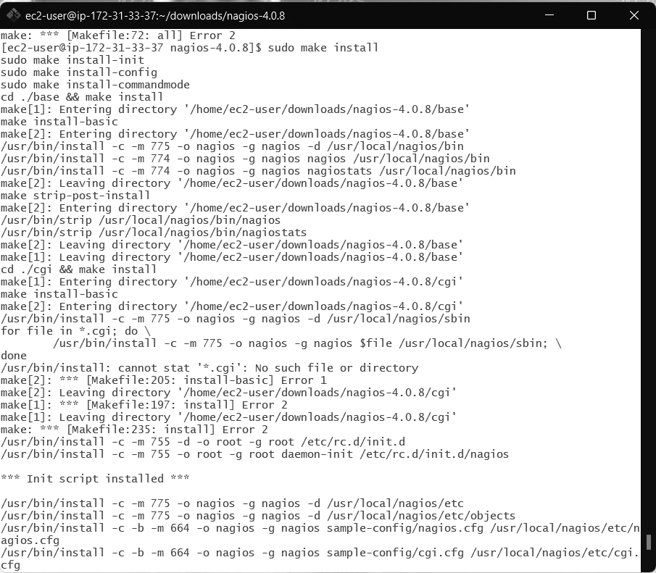

14. Edit the config file and change the email address.

sudo nano /usr/local/nagios/etc/objects/contacts.cfg

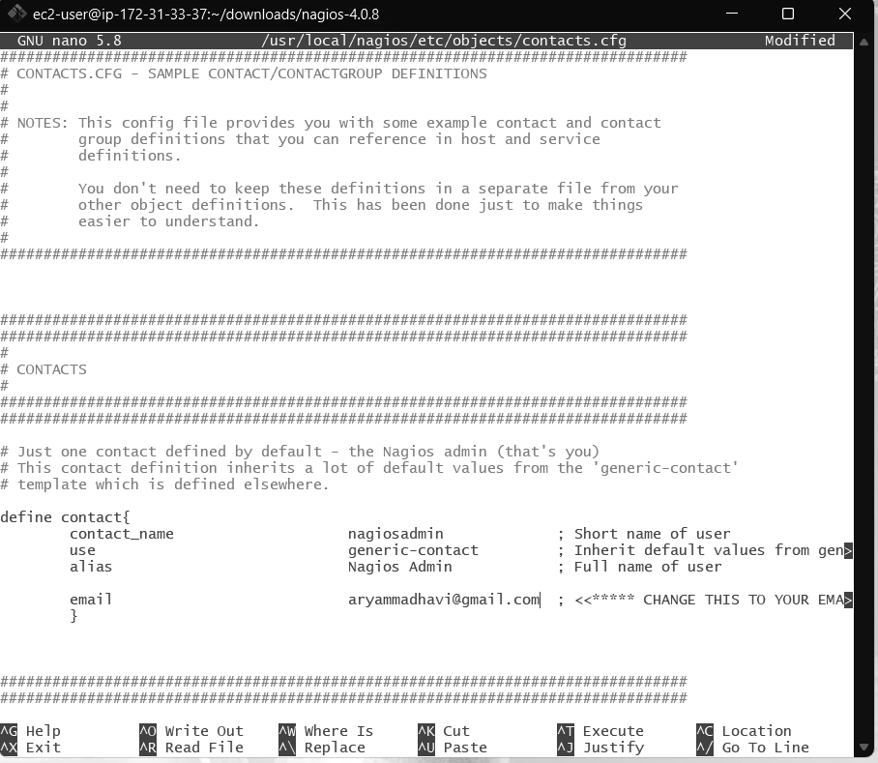15. Configure the web interface.

sudo make install-webconf

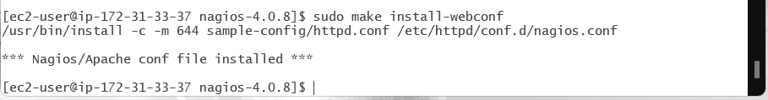

16. Create a nagiosadmin account for nagios login along with password. You’ll have to specify the password twice.

sudo htpasswd -c /usr/local/nagios/etc/htpasswd.users nagiosadmin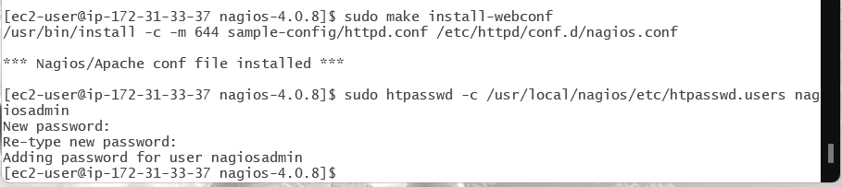

17. Restart Apache

sudo service httpd restart

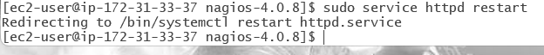

18. Go back to the downloads folder and unzip the plugins zip file.

cd ~/downloads

tar zxvf nagios-plugins-2.0.3.tar.gz

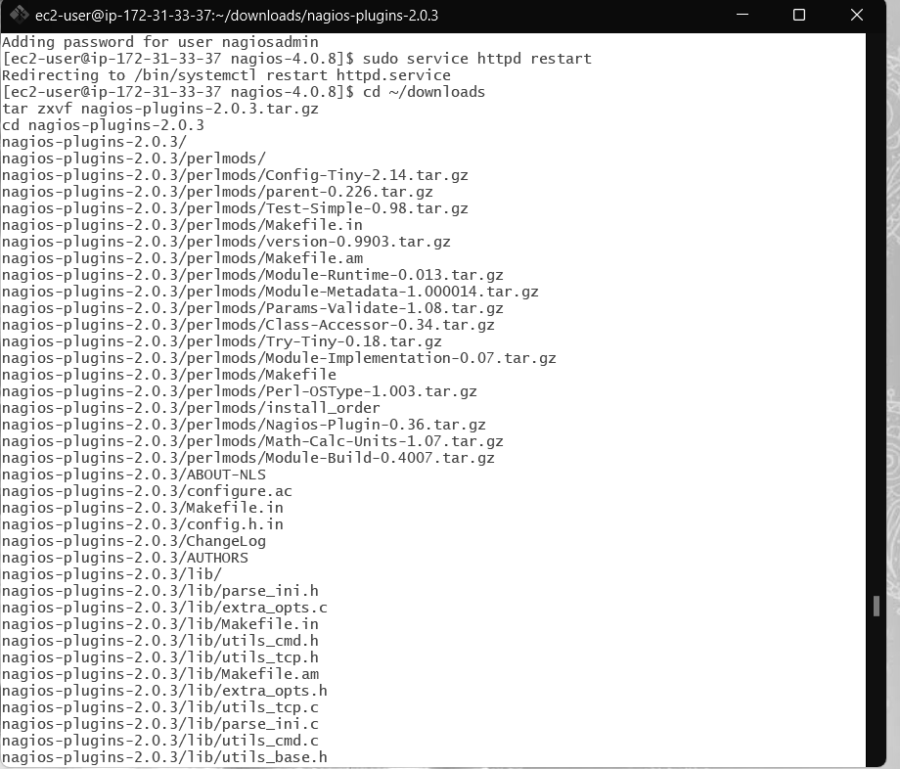

19. Compile and install plugins

cd nagios-plugins-2.0.3

./configure --with-nagios-user=nagios --with-nagios-group=nagios make

sudo make install

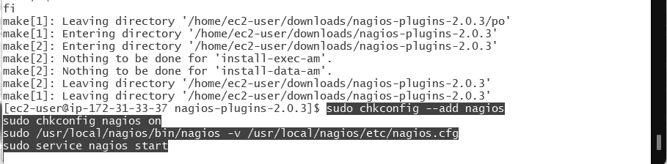

20. Start Nagios

Add Nagios to the list of system services

sudo chkconfig --add nagios

sudo chkconfig nagios on

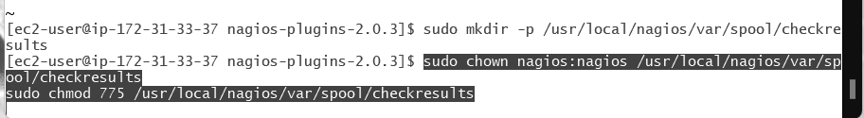

Verify the sample configuration files

sudo /usr/local/nagios/bin/nagios -v /usr/local/nagios/etc/nagios.cfg If there are no errors, you can go ahead and start Nagios.

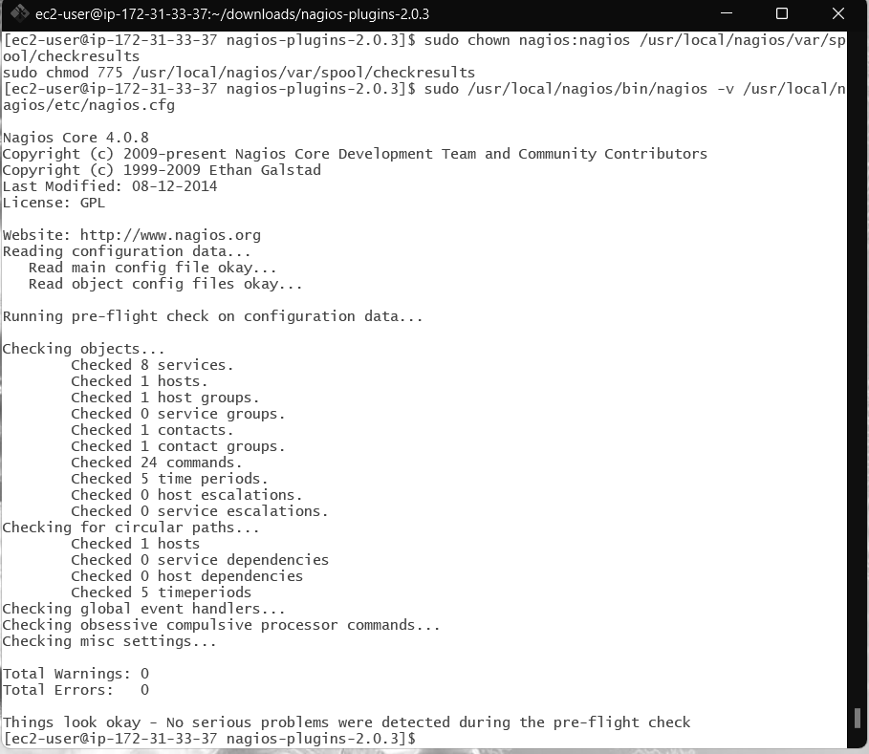

sudo service nagios start



21. Check the status of Nagios

sudo systemctl status nagios

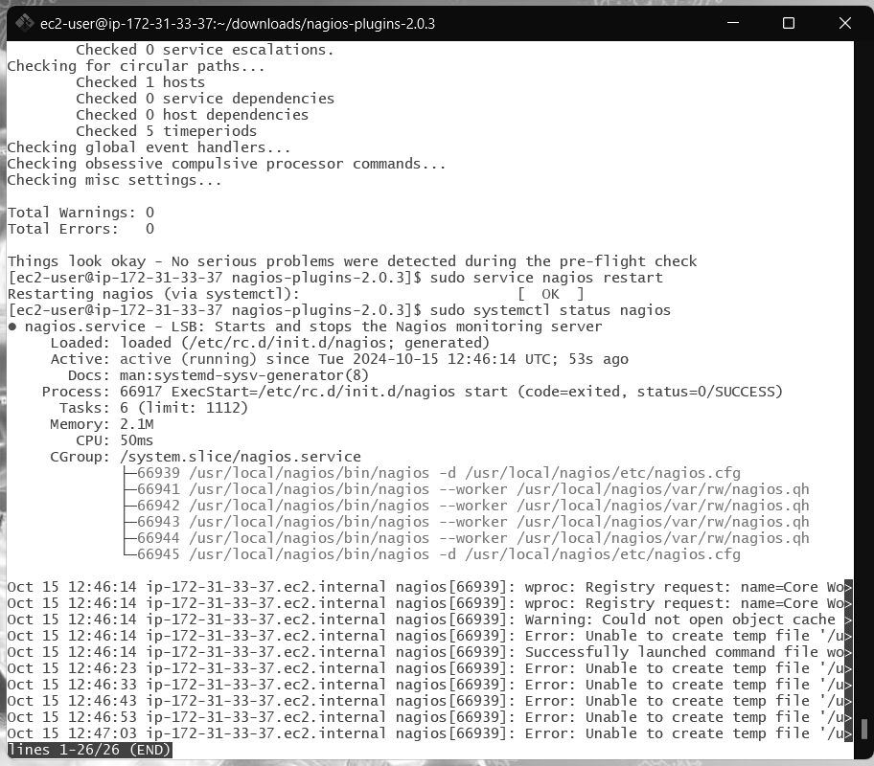

22. Go back to EC2 Console and copy the Public IP address of this instance

23. Open up your browser and look for **http://<your_public_ip_address>/nagios** Enter username as nagiosadmin and password which you set in Step 16.

After entering the correct credentials, you will see this page.

This means that Nagios was correctly installed and configured with its plugins so far.

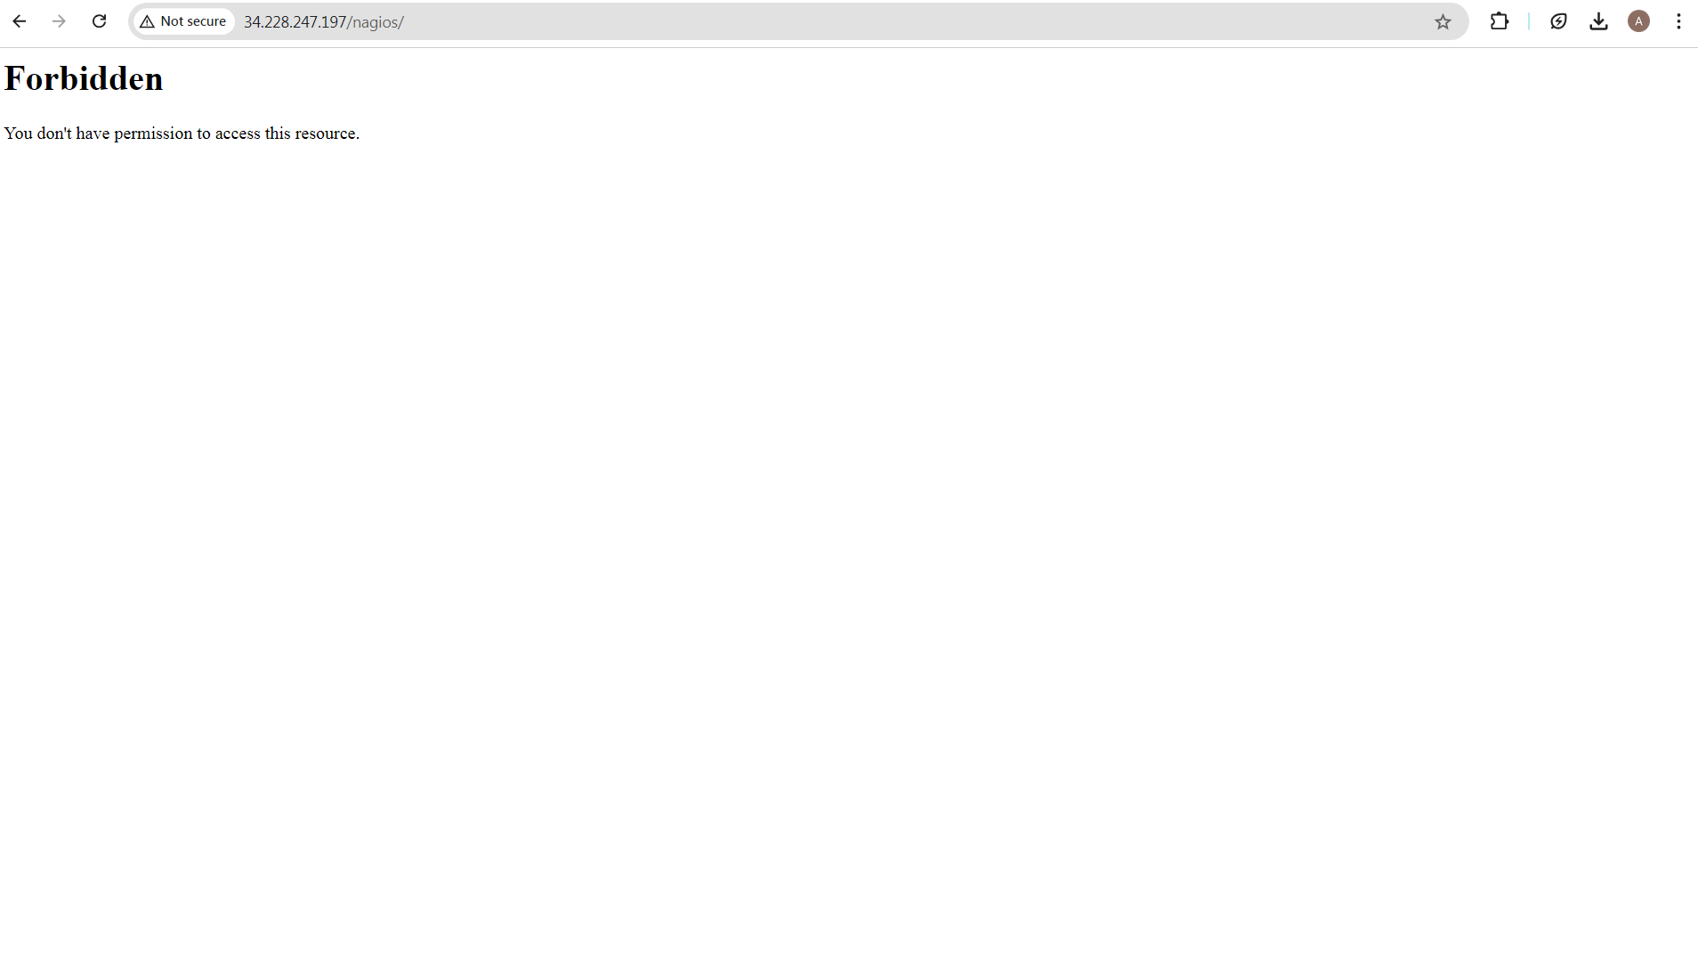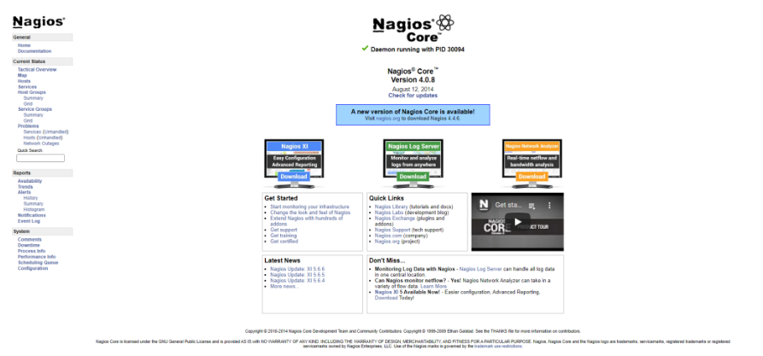

**Conclusion:**

Thus, we learned about Nagios and successfully set it up as a host on our Amazon Linux machine.